1)

Use (3-to-8) Decoder's to design a multiplier circuit that multiply two numbers, each number have two bits

2)

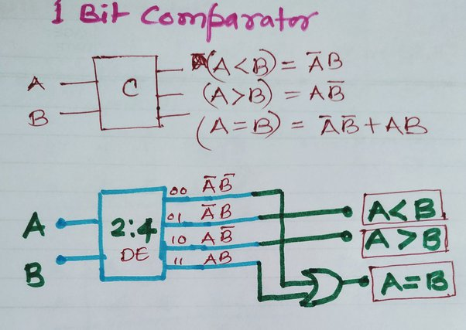

3)

<https://www.quora.com/How-do-I-implement-a-boolean-function-using-decoder>

4) <https://freakengineer.com/full-subtractor-using-multiplexer/#:~:text=Full%20subtractor%20using%20multiplexer.,gate%2C%20and%20one%20OR%20gate>.

<https://www.quora.com/How-do-to-implement-full-subtractor-using-4-1-multiplexer>

5)

6)

7)

<https://stackoverflow.com/questions/38192077/k-map-karnaugh-map-8-4-2-1-to-binary-code-conversion>

8)

<https://www.google.com/search?q=8Using+truth+table+and+K-maps+design+the+BCD+to+seven+segment+decoder+using+minimum+number+of+gates.+The+six+invalid+combinations+should+result+in+a+blank+display&sourceid=chrome&ie=UTF-8>

9)